778-154-94-69
E-mail: banu_12.-01@mail.ru

ХАЙЫПНАЗАРҚЫЗЫ Гүлбану,
З.Космодемьянская атындағы №23 мектеп-лицейінің ағылшын тілі пәні мұғалімі.
Шымкент қаласы

WEATHER CONDITIONS

Learning objectives (s) that this lesson is contributing to |  | 6.C2 use speaking and listening skills to provide sensitive feedback to peers  6.L5 understand most specific information and detail of short, supported talk on a wide range of familiar topics  6.S7 use appropriate subject-specific vocabulary and syntax to talk about a limited range of general topics  6.S3 give an opinion at sentence level on a limited range of general and curricular topics
Lesson objectives |  | Learners will be able to:
- Understand classroom instructions
- Apply the appropriate subject- specific vocabulary
- Learn adjectives belong to the weather
Plan
Time | Teacher actions |  | Pupil actions | Assessment | Resources
5 min | Greeting of the learners and introduces the Lesson Objectives in a simplified manner |  | Greets teacher
5 min  5 min  5 min  5 min  5 min  10 min | Greetings:  Good afternoon students! Who is on duty today? Who is absent?  1. Checks homework.  2.Introduces new vocabulary.  Sunny – күн шуақты  Cold - суық  Foggy – тұманды  Windy – желді  Icy – мұзды  Snowy – қарлы  Hot – ыстық  Rainy – жаңбырлы  Cloudy – бұлтты  Stormy - дауылды  3. Task 1. Match the nouns with adjectives in new vocabulary. Which word doesn’t change?  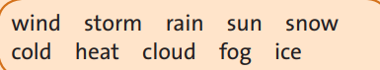  Differentiation:  Less able students: do the tasks with support  More able students: do the tasks without support  4.Task 2. Choose the correct words.  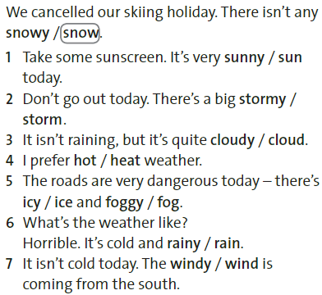  Differentiation:  Less able students: do the tasks with support  More able students: do the tasks without support  5. Task 3. Label the weather symbols with the adjectives in exercise 2.  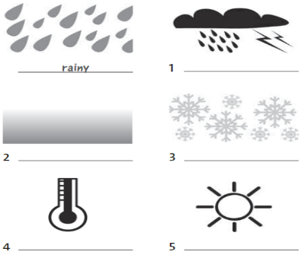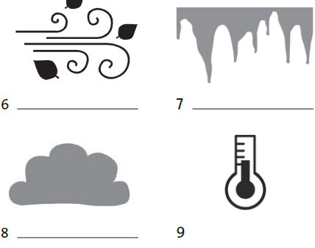  Differentiation:  Less able students: do the tasks with support  More able students: do the tasks without support  6. Task 4. Look at the weather forecast map and complete the sentences. Use the adjectives in exercise 1.  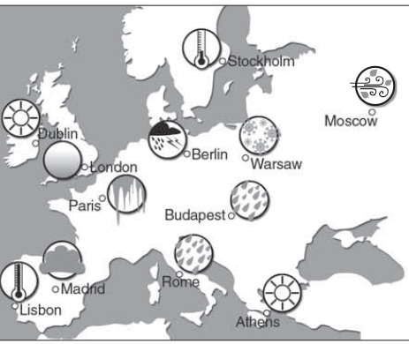  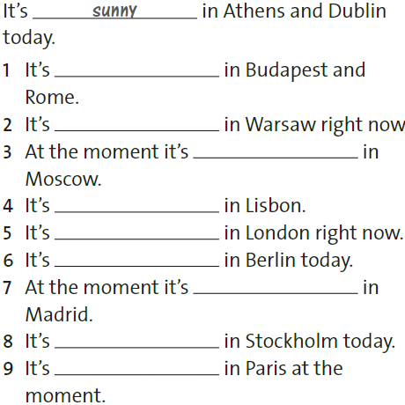  Differentiation:  Less able students: do the tasks with support  More able students: do the tasks without support  7.Task 5. Imagine you are in these places. Write sentences about the weather.  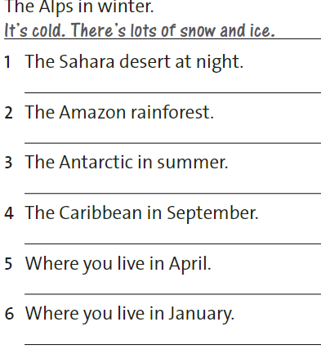Differentiation Less able students: do the tasks with support More able students: do the tasks without support |  | Does homework  Learns new words. Writes down to his dictionary  Matches nouns with adjectives.  Chooses the correct words  Complete the sentences with new vocabulary.  Matches the pictures with the adjectives  Completes the sentences with the right adjectives following the picture.  Writes the sentences about the weather by own sight. | Teacher's assessment \ Mutual assessment  Descriptor:  1. Learn new words  2. Repeat pronunciations of the words  Teacher's assessment \ Mutual assessment  Descriptor:  1. Choose the correct words.  Teacher's assessment  Descriptor: a learner  1. Find the correct words.  Teacher's assessment  Descriptor: a learner  1. Find the adjectives belong to the given weather symbols  Teacher's assessment  Descriptor: a learner  1. Complete the sentences with the correct adjectives  Teacher's assessment  Descriptor: a learner  1. Write the sentences with the correct adjectives | Smartboard  SB (72)  SB p72  WB p50  WB p50  WB p50  WB p50
5 min | Homework:

